***Basics of scripting in linux***

* Topic:- CRUD
  + C 🡪 Create
  + R 🡪 Read
  + U 🡪 Update
  + D 🡪 Delete
* Here we are going run all this type of instruction by using ‘ssh’.
  + CSV🡪 variables are differed by ‘ , ‘(coma).[name,email,result]
  + TSV 🡪 variables are differed by ‘ ‘(TAB).[ name email]
  + CUT [This is used for U]🡪 when you want to clean/filter your data.(like I just want to see the names).
  + SED(string editer)[This is used for U] 🡪
* 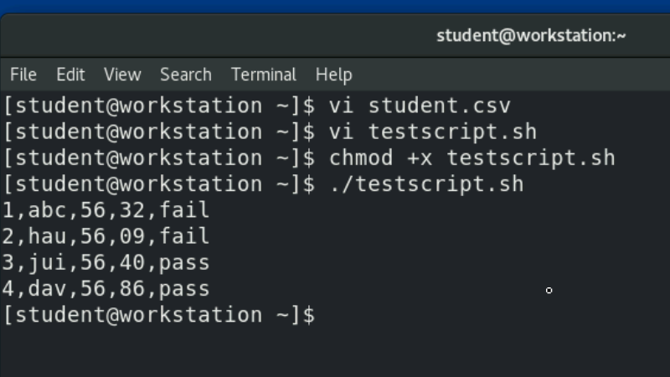
  + 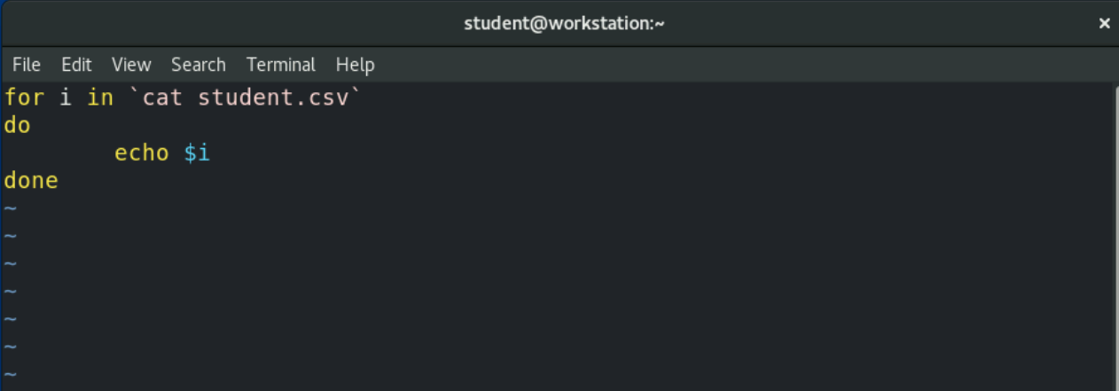
  + This all comes under read statement
  + 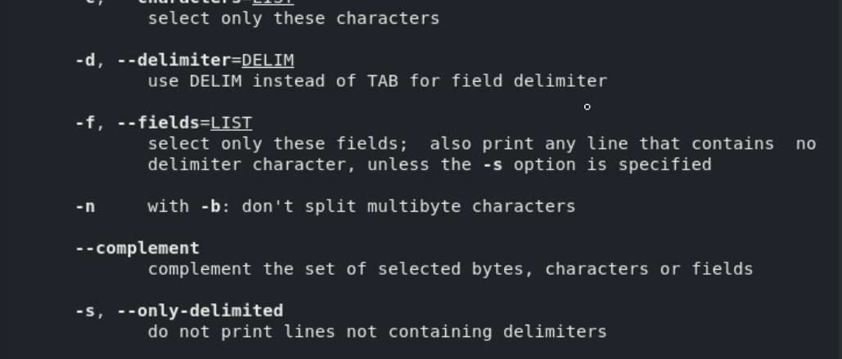
    - About man of cut